**________________________________________________________________**

**ERP brochure**

* **-Who we are ? about quiq**

QUIQ ERP gives full solution for all your business needs in one package; you do not have to use spread sheets and other application packages to do multi task. We understand what is require to run a company and we have provided all in package... for you!

QUIQ ERP integrates business processes across suppliers, partners, employees and customers to create a more effective organization from a strategic decision level to daily operations. Insight into production, inventory and financial data makes it easy to identify opportunities for cost savings and efficiency improvements. A high-level view of key business indicators facilitates faster and more accurate management decisions.

We believe in perfection and doing it right in the first time itself!

* -Graphic to represent highlighted features **Why quiq ?**
* **Easy browsing**
* **Duplicate Alerts & Blocking**
* **Customize Yourself**
* **Easy Backup**

**With QUIQ ERP Administrator you…**

* Automate authorization processes and reduce paperwork
* Ensure proper privileges and access rights
* Protect sensitive information where necessary
* Enforce business rules through automation
* Database Backup facility is also available.
* **Benefits of quiq**

QUIQ ERP Enterprise is built and deployed on the MS SQL Platform, a standard that is unmatched in the industry. With the QUIQ ERP Enterprise, you get following Advantages and Benefits

* Improved efficiency
* Intelligent decision-making
* Reduced expenses
* Improved customer service
* Better planning and forecasting
* Enhanced communication
* Optimized inventory
* Increased accuracy
* Improved reliability
* Simplified management
* Transformation of your small business
* Seamless Integration
* Scalability
* Adaptability
* Ease of Implementation
* Increased profitability
* Lower total cost of ownership
* Industry expertise
* **Diagrammatic representation for below ( SAAS /Modules )**
* Sales & Imports

Comprehensive sales management module which monitors sales right from the quotation stage up to invoicing

* Purchase

Process starting from the estimate of supplies needed, through specific stages of the supply orders, managing the reception of goods

* Inventory management

Inventory management system that unlocks the value of your Inventory control processes through better controls on receipts, storage movement and analysis of stocks.

* Production & planning

It utilizes the resource allocation of activities of employees, materials and production capacity, in order to serve different customers

* Asset management

Feature built into the accounting system that allows us to define the category of an asset, classify assets to compute the depreciation

* Accounting & financials

Unlocks the value of your financial processes by significantly enhancing data availability, financial controls and comprehensive financial reporting, throughout the enterprise

* Real Time Integrator

Ingests real-time data from a wide variety of sources including databases, log files, IoT devices, message queues, for different data types such as JSON, XML, delimiter

* Manufacturing

QuiqERP Track, measure, and monitor your entire business, from shop floor to top floor and from raw materials to final product

* Cloud based solution
* 24/7 support

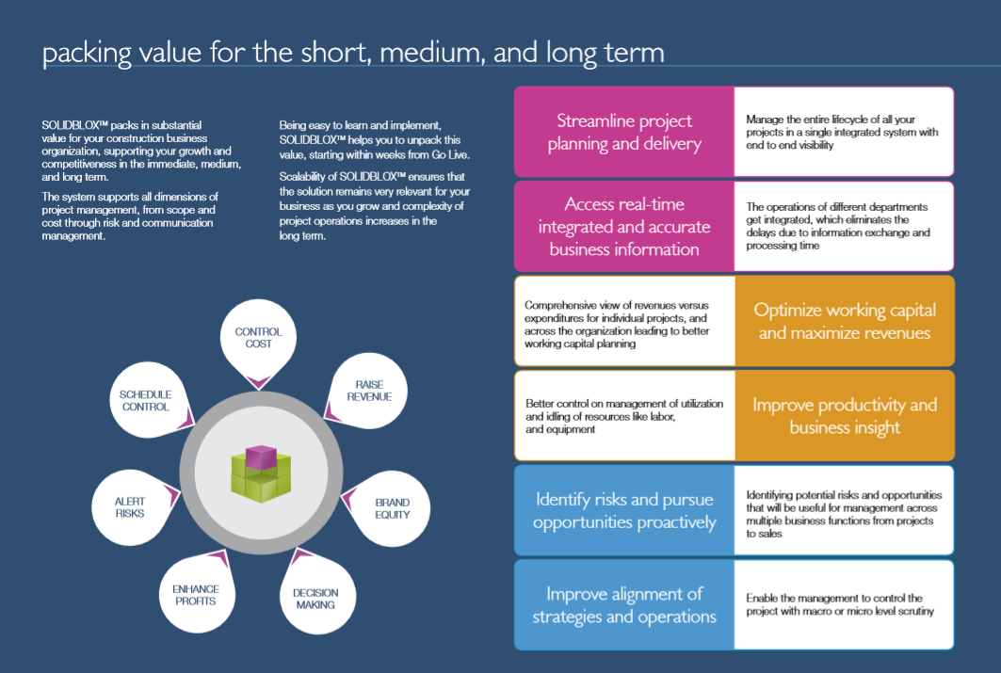

**Our Packaging Value for the short, medium & long term**

Scalability of QuiqERP ensures that the solution remains very relevant for your business as you grow and complexity of project operations increases in the long term.

* Being easy to learn and implement
* Streamline project planning and delivery
* Manage the entire lifecycle of all your projects in a single integrated system with end to end visibility
* Access real-time integrated and accurate business information
* The operations of different location, departments, get integrated, which eliminates the delays due to information exchange and processing time
* Comprehensive view of revenues versus expenditures for individual projects, and across the organization leading to better working capital planning
* Optimize working capital and maximize revenues
* Better control on management of utilization and idling of resources like labors and assets
* Improve productivity and business insight
* Identify risks and pursue opportunities proactively
* Improve alignment of strategies and operations

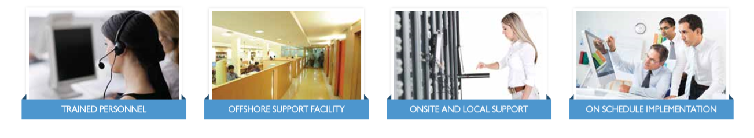

* **Contact**